

Student Name | Sarvesh Naik
SRN No | 31241943
Roll No | 33
Program | Computer Engineering
Year | Third Year
Division | F
Subject | Artificial Intelligence Lab
Assignment No | 4

Assignment 4

Problem Statement: Implement the Best First Search to solve the following problems:
a. 8 puzzle b. Robot Navigation problem c. Cities Distance (shortest path) problem

Objective:
The objective of this experiment is to implement the Best First Search algorithm to solve different types of Artificial Intelligence search problems.
Best First Search is a heuristic-based search technique that explores the most promising node first using an evaluation function. The goal of this experiment is to understand how heuristic search improves efficiency while solving complex state-space problems.
This algorithm is applied to the following problems:
- 8-Puzzle Problem
- Robot Navigation Problem
- Cities Distance (Shortest Path) Problem
Through this implementation, we analyze how Best First Search selects nodes using heuristic values and finds optimal or near-optimal solutions efficiently.

What is Best First Search?
Best First Search (BFS) is an informed search algorithm that expands the node that appears to be closest to the goal based on a heuristic function.
Unlike uninformed search methods like BFS or DFS, Best First Search uses problem-specific knowledge (heuristics) to guide the search.
It works by maintaining a priority queue (open list) of nodes sorted by an evaluation function.
The node with the lowest heuristic value (best estimated path to the goal) is expanded first.

The general evaluation function used in Best First Search is:
f(n)=h(n)f(n) = h(n)f(n)=h(n)
Where:
- f(n) → evaluation function
- h(n) → heuristic estimate of the cost from node n to goal
For some variations (like A* search):
f(n)=g(n)+h(n)f(n) = g(n) + h(n)f(n)=g(n)+h(n)
Where:
- g(n) → cost from start node to node n
- h(n) → estimated cost from node n to goal
But Greedy Best First Search uses only
f(n)=h(n)f(n) = h(n)f(n)=h(n)

1. 8 Puzzle Problem
The 8-Puzzle Problem is a classic problem in Artificial Intelligence used to demonstrate state space search algorithms such as Best First Search.
The puzzle consists of a 3 × 3 grid containing eight numbered tiles (1–8) and one blank space. The blank space is used to move the tiles around the board.
The objective of the problem is to rearrange the tiles from an initial configuration to a goal configuration by sliding tiles into the blank space.
In the 8-puzzle problem, every arrangement of tiles on the board represents a state.
A state can be represented as a 3×3 matrix or array, where each position contains a tile number or a blank.

Working:
- Start with the initial puzzle state.
- Calculate heuristic value.
- Insert the state into the priority queue.
- Select the node with the lowest heuristic value.
- Generate new states by moving the blank tile.
- Compute heuristic for each new state.
- Add new states to the queue.
- Continue until goal state is reached.

Pseudo Code:
BestFirstSearch(start, goal):

open_list = priority queue
closed_list = empty set

insert start into open_list

while open_list is not empty:

current = remove node with lowest h(n)

if current == goal:
return solution path

add current to closed_list

generate successors of current

for each successor:
if successor not in closed_list:
calculate h(successor)
insert successor into open_list

return failure

Code:
"""
8-Puzzle — Best First Search with Full Tree Visualization
==========================================================
Heuristic : Manhattan Distance
pip install matplotlib
python bfs_8puzzle.py
"""

import heapq, uuid, sys, math
import matplotlib.pyplot as plt
import matplotlib.patches as mpatches
import matplotlib.patheffects as pe

# ── CONFIGURATION ──────────────────────────────────────────────────
GOAL_STATE = (1, 2, 3, 8, 0, 4, 7, 6, 5)
GOAL_POS = {val: idx for idx, val in enumerate(GOAL_STATE)}

# Initial state → change here to test others
# (2,8,3, 1,6,4, 7,0,5) is a classic 5-move puzzle
INIT_STATE = (2, 8, 3,
1, 6, 4,
7, 0, 5)

# ── HEURISTIC ──────────────────────────────────────────────────────
def manhattan(state):
d = 0
for idx, tile in enumerate(state):
if tile == 0:
continue
gi = GOAL_POS[tile]
d += abs(idx//3 - gi//3) + abs(idx%3 - gi%3)
return d

# ── SUCCESSORS ─────────────────────────────────────────────────────
MOVE_NAMES = {(-1,0):"↑ Up", (1,0):"↓ Down", (0,-1):"← Left", (0,1):"→ Right"}

def successors(state):
blank = state.index(0)
r, c = divmod(blank, 3)
result = []
for dr, dc in [(-1,0),(1,0),(0,-1),(0,1)]:
nr, nc = r+dr, c+dc
if 0 <= nr < 3 and 0 <= nc < 3:
nb = nr*3 + nc
s = list(state)
s[blank], s[nb] = s[nb], s[blank]
result.append((tuple(s), MOVE_NAMES[(dr,dc)]))
return result

# ── BEST FIRST SEARCH + TREE BUILD ─────────────────────────────────
# nodes dict: id -> {state, depth, parent, label, status, h, children}

nodes = {}
visit_order = [0]
goal_id = [None]

root_id = "root"
nodes[root_id] = {
"state": INIT_STATE, "depth": 0, "parent": None,
"label": "", "status": "start", "h": manhattan(INIT_STATE),
"children": [], "visit_num": 0
}

# BFS-style: expand best h(n) first, record ALL nodes explored
# We also add "rejected" (already visited) siblings to the tree for visualization

open_heap = [] # (h, counter, node_id)
visited = {} # state -> node_id (first time we expand this state)
counter = [0]

def push(nid):
counter[0] += 1
heapq.heappush(open_heap, (nodes[nid]["h"], counter[0], nid))

push(root_id)
visited[INIT_STATE] = root_id

while open_heap and goal_id[0] is None:
h_val, _, nid = heapq.heappop(open_heap)
nd = nodes[nid]

if nd["status"] == "pruned":
continue # duplicate in heap (lazy deletion)
if nd["state"] in visited and visited[nd["state"]] != nid:
nd["status"] = "pruned"
continue

if nd["status"] not in ("start", "solution", "goal"):
visit_order[0] += 1
nd["visit_num"] = visit_order[0]

if manhattan(nd["state"]) == 0: # goal check
nd["status"] = "goal"
goal_id[0] = nid
break

for nxt_state, lbl in successors(nd["state"]):
cid = str(uuid.uuid4())[:8]
h = manhattan(nxt_state)
if nxt_state in visited:
# Already visited — show as pruned leaf in tree
nodes[cid] = {
"state": nxt_state, "depth": nd["depth"]+1,
"parent": nid, "label": lbl, "status": "pruned",
"h": h, "children": [], "visit_num": None
}
nd["children"].append(cid)
else:
visit_order[0] += 1
nodes[cid] = {
"state": nxt_state, "depth": nd["depth"]+1,
"parent": nid, "label": lbl, "status": "new",
"h": h, "children": [], "visit_num": visit_order[0]
}
nd["children"].append(cid)
visited[nxt_state] = cid
push(cid)

if goal_id[0] is None:
print("No solution found."); sys.exit()

# Mark solution path
sol_ids = set()
nid = goal_id[0]
while nid:
sol_ids.add(nid)
nid = nodes[nid]["parent"]
for nid in sol_ids:
if nodes[nid]["status"] not in ("start","goal"):
nodes[nid]["status"] = "solution"

goal_depth = nodes[goal_id[0]]["depth"]
total_nodes = len(nodes)
pruned_count = sum(1 for n in nodes.values() if n["status"] == "pruned")

# Print solution path
print("\n 8-PUZZLE — Best First Search Solution")
print(" " + "─"*45)
path_ids = []
nid = goal_id[0]
while nid:
path_ids.append(nid)
nid = nodes[nid]["parent"]
path_ids.reverse()
for step, nid in enumerate(path_ids):
s = nodes[nid]["state"]
h = nodes[nid]["h"]
lbl = nodes[nid]["label"]
print(f" Step {step} h={h} {lbl}")
for row in range(3):
print(" " + " ".join(str(s[row*3+c]) if s[row*3+c] else "_" for c in range(3)))
print(f"\n Solved in {goal_depth} moves | Nodes in tree: {total_nodes} | Pruned: {pruned_count}")

# ── LAYOUT ──────────────────────────────────────────────────────────
sys.setrecursionlimit(50000)

def assign_x(nid, counter):
ch = nodes[nid]["children"]
if not ch:
nodes[nid]["x"] = counter[0] * 1.0
counter[0] += 1
return
for c in ch:
assign_x(c, counter)
xs = [nodes[c]["x"] for c in ch]
nodes[nid]["x"] = (min(xs)+max(xs))/2.0

assign_x(root_id, [0])
for nid, nd in nodes.items():
nd["y"] = -nd["depth"] * 2.2

all_x = [nd["x"] for nd in nodes.values()]
x_span = max(all_x) - min(all_x) + 1
scale = max(1.8, 14.0 / x_span)
for nd in nodes.values():
nd["x"] *= scale

# ── COLORS ──────────────────────────────────────────────────────────
C_BG = "#0a0a1a"
C_START = "#FF8C00"
C_SOL = "#FFD700"
C_GOAL = "#00E676"
C_NEW = "#4A6FA5"
C_PRUNED = "#B71C1C"
C_SOLEDGE = "#FFD700"
C_NEWEDGE = "#4A6FA5"
C_PRUNEDGE= "#B71C1C"
C_BT = "#FF4081"

def node_color(s):
return {"start":C_START,"solution":C_SOL,"goal":C_GOAL,
"new":C_NEW,"pruned":C_PRUNED}.get(s, C_NEW)

# ── FIGURE ──────────────────────────────────────────────────────────
all_x2 = [nd["x"] for nd in nodes.values()]
all_y2 = [nd["y"] for nd in nodes.values()]
W = max(20, (max(all_x2)-min(all_x2)+5))
H = max(16, abs(min(all_y2))+5)

fig, ax = plt.subplots(figsize=(W, H))
fig.patch.set_facecolor(C_BG)
ax.set_facecolor(C_BG)

NODE_R = 0.48

# ── DRAW EDGES ──────────────────────────────────────────────────────
for nid, nd in nodes.items():
if nd["parent"] is None: continue
par = nodes[nd["parent"]]
x0,y0 = par["x"], par["y"]
x1,y1 = nd["x"], nd["y"]
is_sol = (nid in sol_ids and nd["parent"] in sol_ids)
is_pruned = nd["status"] == "pruned"
col = C_SOLEDGE if is_sol else (C_PRUNEDGE if is_pruned else C_NEWEDGE)
lw = 2.8 if is_sol else 1.2
ls = "solid" if (is_sol or not is_pruned) else (0,(6,3))
ax.annotate("", xy=(x1, y1+NODE_R), xytext=(x0, y0-NODE_R),
arrowprops=dict(arrowstyle="-|>", color=col, lw=lw,
linestyle=ls, mutation_scale=14,
connectionstyle="arc3,rad=0.0"), zorder=2)
ex = (x0+x1)/2 + 0.1
ey = (y0+y1)/2
ax.text(ex, ey, nd["label"], fontsize=7, color=col,
ha="center", va="center", zorder=4,
bbox=dict(boxstyle="round,pad=0.15", fc=C_BG, ec=col, lw=0.6, alpha=0.9))

# ── BACKTRACK ARROWS ────────────────────────────────────────────────
for nid, nd in nodes.items():
if nd["status"] != "pruned": continue
par = nodes[nd["parent"]]
ax.annotate("",
xy=(par["x"], par["y"]-NODE_R),
xytext=(nd["x"], nd["y"]+NODE_R),
arrowprops=dict(arrowstyle="-|>", color=C_BT, lw=1.6,
linestyle=(0,(5,3)), mutation_scale=13,
alpha=0.85, connectionstyle="arc3,rad=0.5"), zorder=5)

# ── DRAW NODES ──────────────────────────────────────────────────────
for nid, nd in nodes.items():
x, y = nd["x"], nd["y"]
status = nd["status"]
col = node_color(status)
sz = 2200 if status in ("start","goal") else \
1800 if status == "solution" else \
1200 if status == "new" else 900

if status in ("start","solution","goal"):
ax.scatter(x, y, s=sz+900, c=col, alpha=0.12, zorder=3)
ax.scatter(x, y, s=sz, c=col, zorder=6, edgecolors="#ffffff20", linewidths=0.9)

# State label: draw mini 3x3 grid INSIDE the node
s = nd["state"]
tc = "#000000" if status in ("start","solution","goal") else "#FFFFFF"
# Compact representation: row0 / row1 / row2
r0 = "".join(str(v) if v else "_" for v in s[0:3])
r1 = "".join(str(v) if v else "_" for v in s[3:6])
r2 = "".join(str(v) if v else "_" for v in s[6:9])
ax.text(x, y+0.30, r0, ha="center", va="center", fontsize=6.5,
fontweight="bold", color=tc, zorder=7, fontfamily="monospace")
ax.text(x, y, r1, ha="center", va="center", fontsize=6.5,
fontweight="bold", color=tc, zorder=7, fontfamily="monospace")
ax.text(x, y-0.30, r2, ha="center", va="center", fontsize=6.5,
fontweight="bold", color=tc, zorder=7, fontfamily="monospace")

# h(n) label below node
ax.text(x, y-0.68, f"h={nd['h']}", ha="center", va="center",
fontsize=7, color="#AAAACC", zorder=7)

# Visit order badge
vnum = nd.get("visit_num")
if vnum is not None:
vc = C_GOAL if status=="goal" else C_SOL if status=="solution" \
else C_START if status=="start" else "#90CAF9"
ax.text(x-0.62, y+0.62, f"#{vnum}", fontsize=9, fontweight="bold",
color=vc, ha="center", va="center", zorder=8,
path_effects=[pe.withStroke(linewidth=2.5, foreground=C_BG)])

# ✖ on pruned
if status == "pruned":
ax.text(x+0.55, y+0.55, "✖", fontsize=11, color=C_PRUNED,
ha="center", va="center", fontweight="bold", zorder=8,
path_effects=[pe.withStroke(linewidth=2, foreground=C_BG)])

# START / GOAL badges
for nid, txt in [(root_id,"START"),(goal_id[0],"GOAL ★")]:
nd = nodes[nid]
bg = C_START if txt=="START" else C_GOAL
ax.text(nd["x"], nd["y"]+0.85, txt, ha="center", va="center",
fontsize=9, color="#000", fontweight="bold", zorder=9,
bbox=dict(boxstyle="round,pad=0.35", fc=bg, ec=bg, lw=1.8))

# ── LEGEND ──────────────────────────────────────────────────────────
legend_handles = [
mpatches.Patch(color=C_START, label="Start node"),
mpatches.Patch(color=C_SOL, label="Solution path (Best-h route)"),
mpatches.Patch(color=C_GOAL, label="Goal (Manhattan h=0)"),
mpatches.Patch(color=C_NEW, label="Explored node (off solution path)"),
mpatches.Patch(color=C_PRUNED, label="✖ Already visited → skipped"),
mpatches.Patch(color=C_SOLEDGE, label="━━ Solution path edge"),
mpatches.Patch(color=C_NEWEDGE, label="── BFS forward edge"),
mpatches.Patch(color=C_BT, label="↩ Skip arrow (already visited)"),
]
ax.legend(handles=legend_handles, loc="lower left",
facecolor="#1a1a2e", edgecolor="#444466",
labelcolor="white", fontsize=9.5,
framealpha=0.97, borderpad=1.0, handlelength=1.6)

# ── TITLE ───────────────────────────────────────────────────────────
goal_state_str = "1 2 3 / 8 _ 4 / 7 6 5"
ax.set_title(
f"Best First Search │ 8-Puzzle Problem\n"
f"Heuristic = Manhattan Distance h(n) │ Goal: [{goal_state_str}]\n"
f"BFS always expands the node with lowest h(n) • "
f"Solution found at depth {goal_depth} • {total_nodes} tree nodes • {pruned_count} pruned",
color="white", fontsize=12, fontweight="bold",
loc="left", pad=16, linespacing=1.75)

ax.axis("off")
plt.tight_layout()
plt.savefig("bfs_8puzzle.png",
dpi=160, bbox_inches="tight", facecolor=fig.get_facecolor())
print(" Saved → bfs_8puzzle.png")
plt.show()

Output:
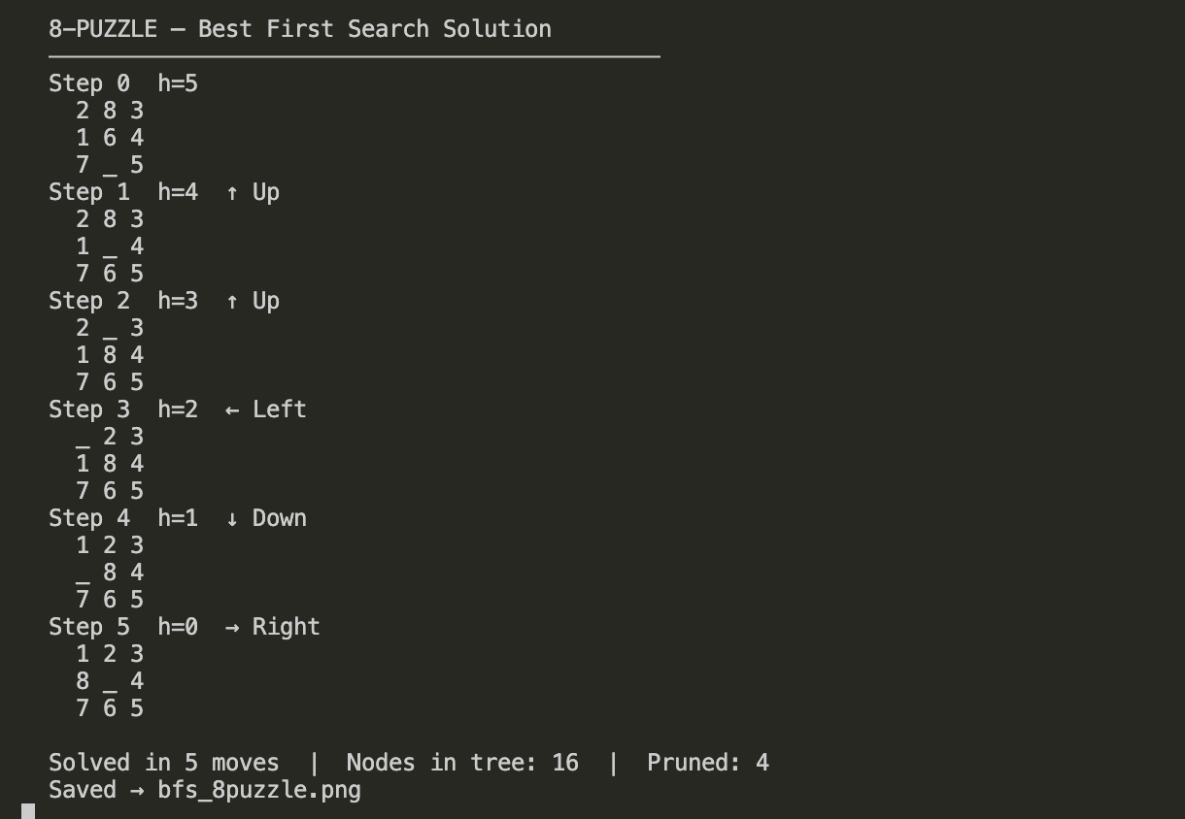
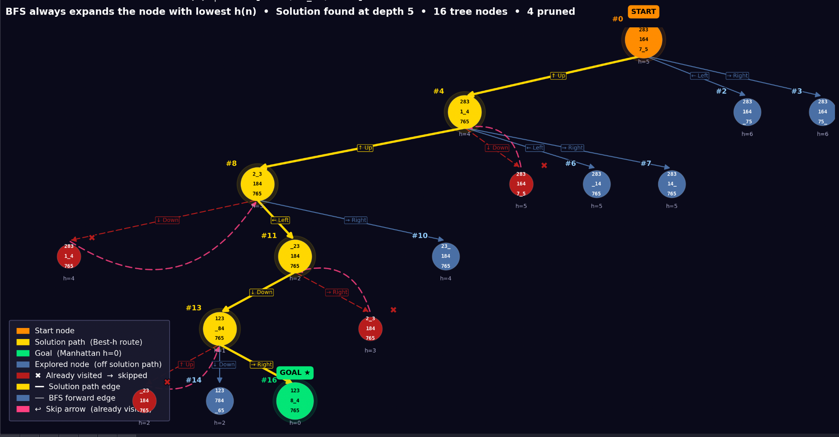

2. Robot Navigation
The Robot Navigation Problem is a common Artificial Intelligence search problem where a robot must move from a starting location to a goal location in an environment while avoiding obstacles.
The environment is usually represented as a 2-dimensional grid or map, where each cell represents a position that the robot can occupy.
Each cell may represent:
- Free space – robot can move there
- Obstacle – robot cannot move there
- Start position – initial location of the robot
- Goal position – target location
The objective is to determine the best path from the start to the goal position.
Best First Search helps in solving this problem by always exploring the grid cell that appears closest to the goal according to a heuristic function.

To guide the search, Best First Search uses a heuristic function that estimates how far the robot is from the goal.
The most commonly used heuristic is the Manhattan Distance.

Manhattan Distance Formula
h(n)=∣xgoal−xcurrent∣+∣ygoal−ycurrent∣h(n) = |x_{goal} - x_{current}| + |y_{goal} - y_{current}|h(n)=∣xgoal​−xcurrent​∣+∣ygoal​−ycurrent​∣
Where:
- (xcurrent, ycurrent) = robot’s current position
- (xgoal, ygoal) = goal position

Working:
- Start from the initial robot position.
- Compute the heuristic value for that position.
- Insert the position into a priority queue (open list).
- Remove the node with the lowest heuristic value.
- Check if it is the goal position.
- If not, generate neighboring positions (up, down, left, right).
- Ignore positions that:
  - Are obstacles
  - Are already visited
- Calculate the heuristic value for each valid neighbor.
- Insert them into the priority queue.
- Repeat the process until the goal position is reached.

Pseudocode:
BestFirstSearch(start, goal):

open_list = priority queue
closed_list = empty set

insert start into open_list with h(start)

while open_list is not empty:

current = node with smallest h(n)

remove current from open_list

if current == goal:
return path

add current to closed_list

for each neighbor of current:

if neighbor is valid and not in closed_list:

compute h(neighbor)

insert neighbor into open_list

return failure

Code:
"""
Robot Navigation — Best First Search with Grid + Search Tree Visualization
===========================================================================
Heuristic : Euclidean Distance to goal
pip install matplotlib
python bfs_robot.py
"""

import heapq, uuid, sys, math
import matplotlib.pyplot as plt
import matplotlib.patches as mpatches
import matplotlib.patheffects as pe
import matplotlib.gridspec as gridspec

# ── GRID ───────────────────────────────────────────────────────────
# '.' = free, '#' = obstacle, 'S' = start, 'G' = goal
GRID = [
['S', '.', '.', '#', '.'],
['.', '#', '.', '.', '.'],
['.', '.', '#', '.', '.'],
['#', '.', '.', '.', '.'],
['.', '.', '#', '.', 'G'],
]

ROWS = len(GRID)
COLS = len(GRID[0])

def find_cell(ch):
for r, row in enumerate(GRID):
for c, cell in enumerate(row):
if cell == ch:
return (r, c)

START = find_cell('S')
GOAL = find_cell('G')

MOVES = [(-1,0,"↑"),(1,0,"↓"),(0,-1,"←"),(0,1,"→")]

def euclidean(state):
return math.sqrt((state[0]-GOAL[0])**2 + (state[1]-GOAL[1])**2)

def get_neighbors(state):
r, c = state
result = []
for dr, dc, lbl in MOVES:
nr, nc = r+dr, c+dc
if 0 <= nr < ROWS and 0 <= nc < COLS and GRID[nr][nc] != '#':
result.append(((nr, nc), lbl))
return result

# ── BEST FIRST SEARCH + TREE BUILD ─────────────────────────────────
nodes = {}
visit_order = [0]
goal_id = [None]
counter = [0]

root_id = "root"
nodes[root_id] = {
"state": START, "depth": 0, "parent": None,
"label": "", "status": "start", "h": euclidean(START),
"children": [], "visit_num": 0
}

open_heap = []
visited = {}

def push(nid):
counter[0] += 1
heapq.heappush(open_heap, (nodes[nid]["h"], counter[0], nid))

push(root_id)
visited[START] = root_id

while open_heap and goal_id[0] is None:
h_val, _, nid = heapq.heappop(open_heap)
nd = nodes[nid]

if nd["state"] in visited and visited[nd["state"]] != nid:
nd["status"] = "pruned"
continue
if nd["status"] == "pruned":
continue

if nd["state"] == GOAL:
nd["status"] = "goal"
goal_id[0] = nid
break

for nxt_state, lbl in get_neighbors(nd["state"]):
cid = str(uuid.uuid4())[:8]
h = euclidean(nxt_state)
if nxt_state in visited:
nodes[cid] = {
"state": nxt_state, "depth": nd["depth"]+1,
"parent": nid, "label": lbl, "status": "pruned",
"h": h, "children": [], "visit_num": None
}
nd["children"].append(cid)
else:
visit_order[0] += 1
nodes[cid] = {
"state": nxt_state, "depth": nd["depth"]+1,
"parent": nid, "label": lbl, "status": "new",
"h": h, "children": [], "visit_num": visit_order[0]
}
nd["children"].append(cid)
visited[nxt_state] = cid
push(cid)

if goal_id[0] is None:
print("No path found."); sys.exit()

# Mark solution path
sol_ids = set()
nid = goal_id[0]
while nid:
sol_ids.add(nid)
nid = nodes[nid]["parent"]
for nid in sol_ids:
if nodes[nid]["status"] not in ("start","goal"):
nodes[nid]["status"] = "solution"

sol_path = []
nid = goal_id[0]
while nid:
sol_path.append(nodes[nid]["state"])
nid = nodes[nid]["parent"]
sol_path.reverse()

goal_depth = nodes[goal_id[0]]["depth"]
total_nodes = len(nodes)
pruned_count = sum(1 for n in nodes.values() if n["status"] == "pruned")

print(f"\n Robot Navigation — Best First Search")
print(f" Path: {' → '.join(str(p) for p in sol_path)}")
print(f" Steps: {goal_depth} | Nodes: {total_nodes} | Pruned: {pruned_count}")

# ── TREE LAYOUT ─────────────────────────────────────────────────────
sys.setrecursionlimit(50000)

def assign_x(nid, ctr):
ch = nodes[nid]["children"]
if not ch:
nodes[nid]["x"] = ctr[0] * 1.0
ctr[0] += 1
return
for c in ch:
assign_x(c, ctr)
xs = [nodes[c]["x"] for c in ch]
nodes[nid]["x"] = (min(xs)+max(xs))/2.0

assign_x(root_id, [0])
for nid, nd in nodes.items():
nd["y"] = -nd["depth"] * 2.0

all_x = [nd["x"] for nd in nodes.values()]
x_span = max(all_x)-min(all_x)+1
scale = max(1.6, 10.0/x_span)
for nd in nodes.values():
nd["x"] *= scale

# ── COLORS ──────────────────────────────────────────────────────────
C_BG = "#0a0a1a"
C_START = "#FF8C00"
C_SOL = "#FFD700"
C_GOAL = "#00E676"
C_NEW = "#4A6FA5"
C_PRUNED = "#B71C1C"
C_SOLEDGE = "#FFD700"
C_NEWEDGE = "#4A6FA5"
C_PRUNEDGE = "#B71C1C"
C_BT = "#FF4081"

def node_color(s):
return {"start":C_START,"solution":C_SOL,"goal":C_GOAL,
"new":C_NEW,"pruned":C_PRUNED}.get(s, C_NEW)

# ── FIGURE: left=grid, right=tree ───────────────────────────────────
all_x2 = [nd["x"] for nd in nodes.values()]
all_y2 = [nd["y"] for nd in nodes.values()]
tree_W = max(14, (max(all_x2)-min(all_x2)+4))
tree_H = max(14, abs(min(all_y2))+4)

fig = plt.figure(figsize=(tree_W+10, max(tree_H, 10)))
fig.patch.set_facecolor(C_BG)
gs = gridspec.GridSpec(1, 2, width_ratios=[1, tree_W/8], figure=fig, wspace=0.04)

ax_grid = fig.add_subplot(gs[0])
ax_tree = fig.add_subplot(gs[1])
ax_grid.set_facecolor(C_BG)
ax_tree.set_facecolor(C_BG)

# ── LEFT: GRID VISUALIZATION ────────────────────────────────────────
sol_set = set(sol_path)

for r in range(ROWS):
for c in range(COLS):
cell = GRID[r][c]
pos = (r, c)
if cell == '#':
fc, ec, txt_col = "#333355", "#555577", "#888899"
lbl = "▪"
elif pos == START:
fc, ec, txt_col = C_START, "#FFAA00", "#000"
lbl = "S"
elif pos == GOAL:
fc, ec, txt_col = C_GOAL, "#00FF88", "#000"
lbl = "G"
elif pos in sol_set:
fc, ec, txt_col = "#2a2a5a", C_SOL, C_SOL
lbl = "★"
elif pos in visited:
fc, ec, txt_col = "#1a2a3a", C_NEW, C_NEW
lbl = "·"
else:
fc, ec, txt_col = "#111128", "#333355", "#444466"
lbl = "."

rect = plt.Rectangle((c-0.5, ROWS-1-r-0.5), 1, 1,
fc=fc, ec=ec, lw=1.5, zorder=1)
ax_grid.add_patch(rect)
ax_grid.text(c, ROWS-1-r, lbl, ha="center", va="center",
fontsize=14, color=txt_col, fontweight="bold", zorder=3)

# Show grid coordinates
ax_grid.text(c, ROWS-1-r-0.35, f"({r},{c})", ha="center", va="center",
fontsize=6.5, color="#666688", zorder=3)

# Show h(n) on visited cells
if pos in visited and pos not in (START, GOAL) and cell != '#':
h = round(euclidean(pos), 2)
ax_grid.text(c, ROWS-1-r+0.35, f"h={h}", ha="center", va="center",
fontsize=6, color="#AAAACC", zorder=3)

# Draw solution path arrows on grid
for i in range(len(sol_path)-1):
r0,c0 = sol_path[i]
r1,c1 = sol_path[i+1]
ax_grid.annotate("",
xy=(c1, ROWS-1-r1), xytext=(c0, ROWS-1-r0),
arrowprops=dict(arrowstyle="-|>", color=C_SOL,
lw=2.5, mutation_scale=20,
connectionstyle="arc3,rad=0.0"), zorder=4)

ax_grid.set_xlim(-0.5, COLS-0.5)
ax_grid.set_ylim(-0.5, ROWS-0.5)
ax_grid.set_aspect('equal')
ax_grid.set_title("Grid Map │ ★ = Solution Path",
color="white", fontsize=11, fontweight="bold", pad=10)
ax_grid.axis("off")

# Grid legend
lg = [
mpatches.Patch(color=C_START, label="S = Start"),
mpatches.Patch(color=C_GOAL, label="G = Goal"),
mpatches.Patch(color=C_SOL, label="★ = Solution path"),
mpatches.Patch(color=C_NEW, label="· = Explored cell"),
mpatches.Patch(color="#333355",label="▪ = Obstacle"),
]
ax_grid.legend(handles=lg, loc="lower left",
facecolor="#1a1a2e", edgecolor="#444466",
labelcolor="white", fontsize=8.5,
framealpha=0.97, borderpad=0.8)

# ── RIGHT: SEARCH TREE ───────────────────────────────────────────────
NODE_R = 0.45

for nid, nd in nodes.items():
if nd["parent"] is None: continue
par = nodes[nd["parent"]]
x0,y0 = par["x"], par["y"]
x1,y1 = nd["x"], nd["y"]
is_sol = (nid in sol_ids and nd["parent"] in sol_ids)
is_pruned = nd["status"] == "pruned"
col = C_SOLEDGE if is_sol else (C_PRUNEDGE if is_pruned else C_NEWEDGE)
lw = 2.8 if is_sol else 1.2
ls = "solid" if (is_sol or not is_pruned) else (0,(6,3))
ax_tree.annotate("", xy=(x1, y1+NODE_R), xytext=(x0, y0-NODE_R),
arrowprops=dict(arrowstyle="-|>", color=col, lw=lw,
linestyle=ls, mutation_scale=14,
connectionstyle="arc3,rad=0.0"), zorder=2)
ex = (x0+x1)/2 + 0.1
ey = (y0+y1)/2
ax_tree.text(ex, ey, nd["label"], fontsize=7, color=col,
ha="center", va="center", zorder=4,
bbox=dict(boxstyle="round,pad=0.15", fc=C_BG, ec=col, lw=0.6, alpha=0.9))

for nid, nd in nodes.items():
if nd["status"] != "pruned": continue
par = nodes[nd["parent"]]
ax_tree.annotate("",
xy=(par["x"], par["y"]-NODE_R),
xytext=(nd["x"], nd["y"]+NODE_R),
arrowprops=dict(arrowstyle="-|>", color=C_BT, lw=1.6,
linestyle=(0,(5,3)), mutation_scale=13,
alpha=0.85, connectionstyle="arc3,rad=0.5"), zorder=5)

for nid, nd in nodes.items():
x, y = nd["x"], nd["y"]
status = nd["status"]
col = node_color(status)
sz = 2000 if status in ("start","goal") else \
1600 if status == "solution" else \
1100 if status == "new" else 850

if status in ("start","solution","goal"):
ax_tree.scatter(x, y, s=sz+800, c=col, alpha=0.12, zorder=3)
ax_tree.scatter(x, y, s=sz, c=col, zorder=6, edgecolors="#ffffff20", linewidths=0.9)

tc = "#000000" if status in ("start","solution","goal") else "#FFFFFF"
ax_tree.text(x, y+0.18, str(nd["state"]), ha="center", va="center",
fontsize=7.5, fontweight="bold", color=tc, zorder=7)
ax_tree.text(x, y-0.25, f"h={nd['h']:.2f}", ha="center", va="center",
fontsize=6.5, color="#AAAACC", zorder=7)

vnum = nd.get("visit_num")
if vnum is not None:
vc = C_GOAL if status=="goal" else C_SOL if status=="solution" \
else C_START if status=="start" else "#90CAF9"
ax_tree.text(x-0.6, y+0.62, f"#{vnum}", fontsize=9, fontweight="bold",
color=vc, ha="center", va="center", zorder=8,
path_effects=[pe.withStroke(linewidth=2.5, foreground=C_BG)])

if status == "pruned":
ax_tree.text(x+0.55, y+0.55, "✖", fontsize=11, color=C_PRUNED,
ha="center", va="center", fontweight="bold", zorder=8,
path_effects=[pe.withStroke(linewidth=2, foreground=C_BG)])

for nid, txt in [(root_id,"START"),(goal_id[0],"GOAL ★")]:
nd = nodes[nid]
bg = C_START if txt=="START" else C_GOAL
ax_tree.text(nd["x"], nd["y"]+0.82, txt, ha="center", va="center",
fontsize=9, color="#000", fontweight="bold", zorder=9,
bbox=dict(boxstyle="round,pad=0.35", fc=bg, ec=bg, lw=1.8))

legend_handles = [
mpatches.Patch(color=C_START, label="Start node"),
mpatches.Patch(color=C_SOL, label="Solution path"),
mpatches.Patch(color=C_GOAL, label="Goal node"),
mpatches.Patch(color=C_NEW, label="Explored node"),
mpatches.Patch(color=C_PRUNED, label="✖ Already visited"),
mpatches.Patch(color=C_BT, label="↩ Skip (already visited)"),
]
ax_tree.legend(handles=legend_handles, loc="lower left",
facecolor="#1a1a2e", edgecolor="#444466",
labelcolor="white", fontsize=8.5,
framealpha=0.97, borderpad=0.8, handlelength=1.4)

ax_tree.set_title("Search Tree │ h(n) = Euclidean Distance",
color="white", fontsize=11, fontweight="bold", pad=10)
ax_tree.axis("off")

# ── MAIN TITLE ───────────────────────────────────────────────────────
fig.suptitle(
f"Best First Search │ Robot Navigation Problem\n"
f"Grid {ROWS}×{COLS} │ Start={START} → Goal={GOAL} │ "
f"Path length={goal_depth} steps │ {total_nodes} tree nodes │ {pruned_count} pruned",
color="white", fontsize=13, fontweight="bold", y=1.01, linespacing=1.7)

plt.savefig("bfs_robot.png",
dpi=160, bbox_inches="tight", facecolor=fig.get_facecolor())
print(" Saved → bfs_robot.png")
plt.show()

Output:
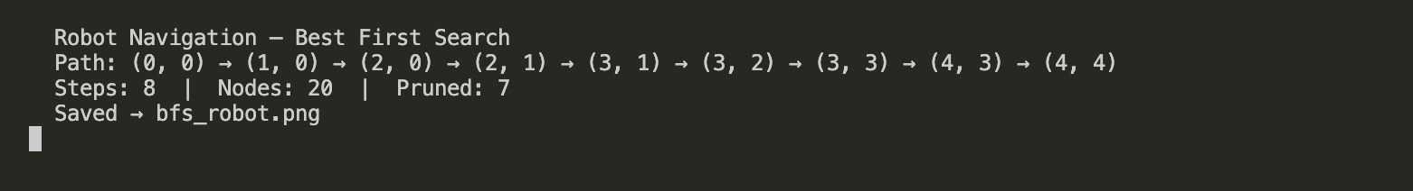
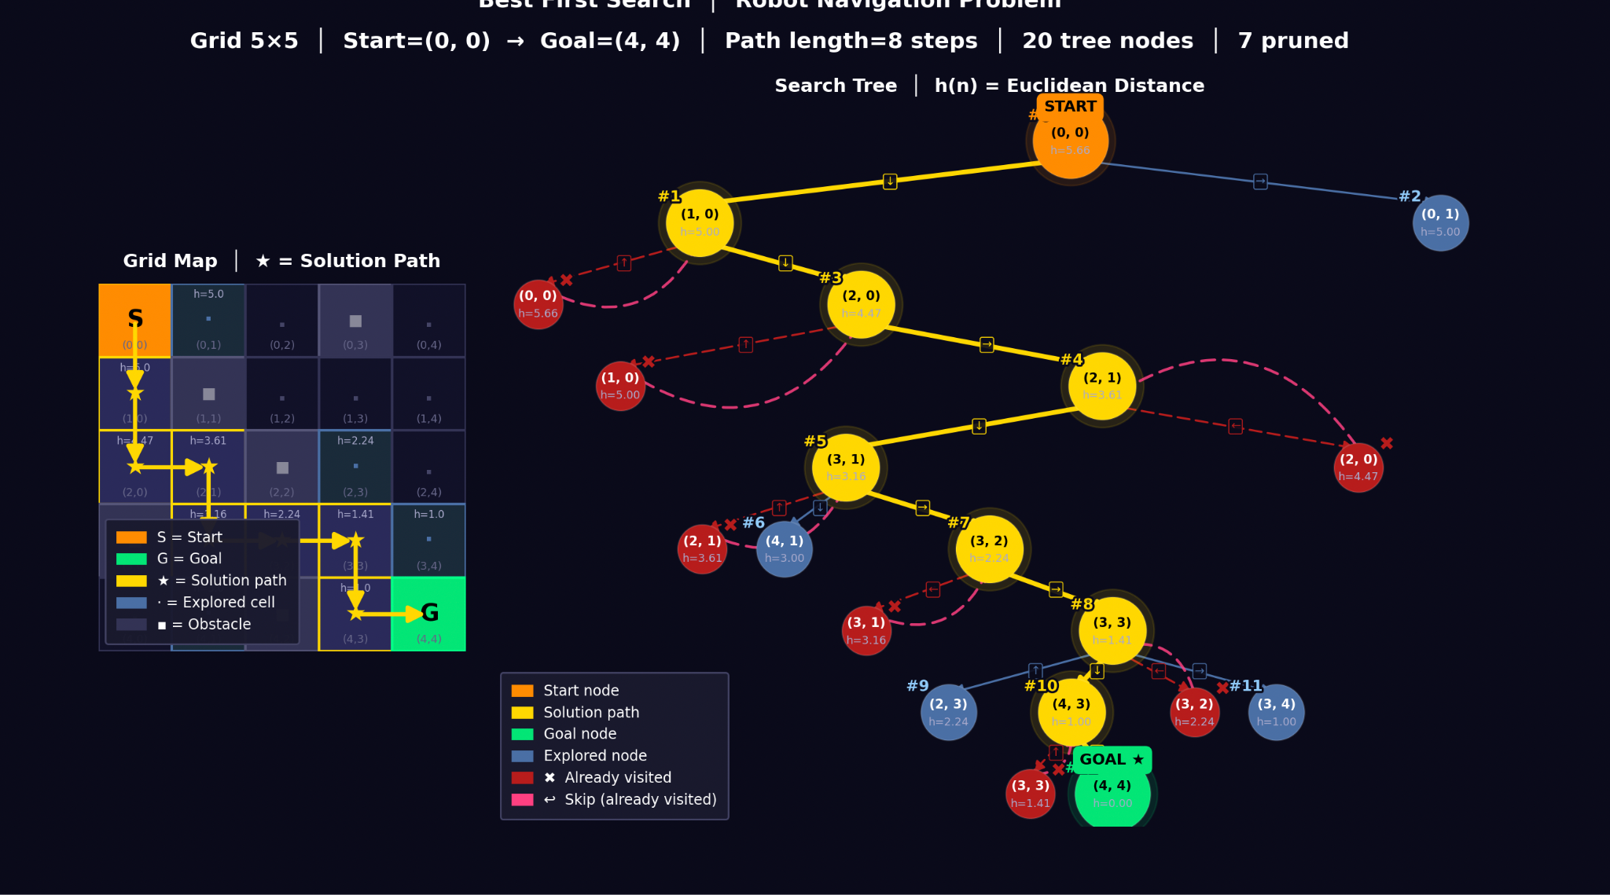
3. Cities Distance
The Cities Distance Problem involves finding the shortest path between two cities in a road network.
This problem is usually represented as a graph where:
- Nodes (vertices) represent cities
- Edges represent roads between cities
- Edge weights represent distances
The road network is represented as a graph:
G=(V,E)G = (V, E)G=(V,E)
Where:
- V = set of cities
- E = set of roads between cities
The heuristic used in this problem is the straight-line distance to the goal city, also called Euclidean distance.
This estimate tells us how close a city is to the destination.

Euclidean Distance Formula
h(n)=(x2−x1)2+(y2−y1)2h(n) = \sqrt{(x_2 - x_1)^2 + (y_2 - y_1)^2}h(n)=(x2​−x1​)2+(y2​−y1​)2​
Where:
- (x1, y1) = coordinates of current city
- (x2, y2) = coordinates of goal city

Working
- Start at the source city.
- Compute heuristic value (distance to destination).
- Insert the city into a priority queue.
- Remove the city with the smallest heuristic value.
- Check if it is the goal city.
- If not, expand the city and explore its neighboring cities.
- Calculate heuristic values for each neighbor.
- Insert neighbors into the priority queue.
- Repeat until the goal city is reached.
Pseudo Code:
BestFirstSearch(start_city, goal_city):

open_list = priority queue
closed_list = empty set

insert start_city into open_list

while open_list is not empty:

current = city with lowest heuristic value

remove current from open_list

if current == goal_city:
return path

add current to closed_list

for each neighboring city:

if neighbor not in closed_list:

compute heuristic value

insert neighbor into open_list

return failure

Code:
"""
Cities Distance — Best First Search with Road Map + Search Tree Visualization
==============================================================================
Romania road map (classic AI textbook — Russell & Norvig)
Heuristic: Straight-line (Euclidean) distance to Bucharest
pip install matplotlib
python bfs_cities.py
"""

import heapq, uuid, sys, math
import matplotlib.pyplot as plt
import matplotlib.patches as mpatches
import matplotlib.patheffects as pe
import matplotlib.gridspec as gridspec

# ── GRAPH DATA ─────────────────────────────────────────────────────
GRAPH = {
'Arad': [('Zerind',75),('Sibiu',140),('Timisoara',118)],
'Zerind': [('Arad',75),('Oradea',71)],
'Oradea': [('Zerind',71),('Sibiu',151)],
'Sibiu': [('Arad',140),('Oradea',151),('Fagaras',99),('Rimnicu',80)],
'Timisoara': [('Arad',118),('Lugoj',111)],
'Lugoj': [('Timisoara',111),('Mehadia',70)],
'Mehadia': [('Lugoj',70),('Drobeta',75)],
'Drobeta': [('Mehadia',75),('Craiova',120)],
'Craiova': [('Drobeta',120),('Pitesti',138),('Rimnicu',146)],
'Rimnicu': [('Sibiu',80),('Craiova',146),('Pitesti',97)],
'Fagaras': [('Sibiu',99),('Bucharest',211)],
'Pitesti': [('Rimnicu',97),('Craiova',138),('Bucharest',101)],
'Bucharest': [('Fagaras',211),('Pitesti',101),('Giurgiu',90),('Urziceni',85)],
'Giurgiu': [('Bucharest',90)],
'Urziceni': [('Bucharest',85),('Hirsova',98),('Vaslui',142)],
'Hirsova': [('Urziceni',98),('Eforie',86)],
'Eforie': [('Hirsova',86)],
'Vaslui': [('Urziceni',142),('Iasi',92)],
'Iasi': [('Vaslui',92),('Neamt',87)],
'Neamt': [('Iasi',87)],
}

# Map coordinates (pixel-style x,y for visualization)
COORDS = {
'Arad': (91, 492), 'Zerind': (75, 449),
'Oradea': (71, 410), 'Sibiu': (207,457),
'Timisoara': (94, 410), 'Lugoj': (165,379),
'Mehadia': (168,339), 'Drobeta': (165,299),
'Craiova': (253,288), 'Rimnicu': (233,410),
'Fagaras': (305,449), 'Pitesti': (320,368),
'Bucharest': (400,327), 'Giurgiu': (375,270),
'Urziceni': (456,350), 'Hirsova': (515,350),
'Eforie': (562,293), 'Vaslui': (540,437),
'Iasi': (473,506), 'Neamt': (406,537),
}

START = 'Arad'
GOAL = 'Bucharest'

def straight_line(city):
x1,y1 = COORDS[city]
x2,y2 = COORDS[GOAL]
return math.sqrt((x1-x2)**2+(y1-y2)**2)

# ── BEST FIRST SEARCH + TREE BUILD ─────────────────────────────────
nodes = {}
visit_order = [0]
goal_id = [None]
counter = [0]

root_id = "root"
nodes[root_id] = {
"state": START, "depth": 0, "parent": None,
"label": "", "status": "start", "h": straight_line(START),
"children": [], "visit_num": 0, "cost": 0
}

open_heap = []
visited = {}

def push(nid):
counter[0] += 1
heapq.heappush(open_heap, (nodes[nid]["h"], counter[0], nid))

push(root_id)
visited[START] = root_id

while open_heap and goal_id[0] is None:
h_val, _, nid = heapq.heappop(open_heap)
nd = nodes[nid]

if nd["state"] in visited and visited[nd["state"]] != nid:
nd["status"] = "pruned"; continue
if nd["status"] == "pruned":
continue

if nd["state"] == GOAL:
nd["status"] = "goal"
goal_id[0] = nid
break

for neighbor, dist in GRAPH.get(nd["state"], []):
cid = str(uuid.uuid4())[:8]
h = straight_line(neighbor)
lbl = f"{dist}km"
if neighbor in visited:
nodes[cid] = {
"state": neighbor, "depth": nd["depth"]+1,
"parent": nid, "label": lbl, "status": "pruned",
"h": h, "children": [], "visit_num": None, "cost": nd["cost"]+dist
}
nd["children"].append(cid)
else:
visit_order[0] += 1
nodes[cid] = {
"state": neighbor, "depth": nd["depth"]+1,
"parent": nid, "label": lbl, "status": "new",
"h": h, "children": [], "visit_num": visit_order[0], "cost": nd["cost"]+dist
}
nd["children"].append(cid)
visited[neighbor] = cid
push(cid)

if goal_id[0] is None:
print("No route found."); sys.exit()

# Mark solution path
sol_ids = set()
nid = goal_id[0]
while nid:
sol_ids.add(nid)
nid = nodes[nid]["parent"]
for nid in sol_ids:
if nodes[nid]["status"] not in ("start","goal"):
nodes[nid]["status"] = "solution"

sol_path = []
nid = goal_id[0]
while nid:
sol_path.append(nodes[nid]["state"])
nid = nodes[nid]["parent"]
sol_path.reverse()
total_dist = nodes[goal_id[0]]["cost"]

goal_depth = nodes[goal_id[0]]["depth"]
total_nodes = len(nodes)
pruned_count = sum(1 for n in nodes.values() if n["status"] == "pruned")

print(f"\n Cities — Best First Search")
print(f" Route: {' → '.join(sol_path)}")
print(f" Distance: {total_dist} km | Nodes: {total_nodes} | Pruned: {pruned_count}")

# ── TREE LAYOUT ─────────────────────────────────────────────────────
sys.setrecursionlimit(50000)

def assign_x(nid, ctr):
ch = nodes[nid]["children"]
if not ch:
nodes[nid]["x"] = ctr[0]*1.0; ctr[0]+=1; return
for c in ch: assign_x(c, ctr)
xs = [nodes[c]["x"] for c in ch]
nodes[nid]["x"] = (min(xs)+max(xs))/2.0

assign_x(root_id, [0])
for nid, nd in nodes.items():
nd["y"] = -nd["depth"]*2.2

all_x = [nd["x"] for nd in nodes.values()]
x_span = max(all_x)-min(all_x)+1
scale = max(1.8, 12.0/x_span)
for nd in nodes.values():
nd["x"] *= scale

# ── COLORS ──────────────────────────────────────────────────────────
C_BG = "#0a0a1a"
C_START = "#FF8C00"
C_SOL = "#FFD700"
C_GOAL = "#00E676"
C_NEW = "#4A6FA5"
C_PRUNED = "#B71C1C"
C_SOLEDGE = "#FFD700"
C_NEWEDGE = "#4A6FA5"
C_PRUNEDGE = "#B71C1C"
C_BT = "#FF4081"
C_ROAD = "#334455"
C_SOLROAD = "#FFD700"

def node_color(s):
return {"start":C_START,"solution":C_SOL,"goal":C_GOAL,
"new":C_NEW,"pruned":C_PRUNED}.get(s, C_NEW)

# ── FIGURE: top=map, bottom=tree ────────────────────────────────────
all_x2 = [nd["x"] for nd in nodes.values()]
all_y2 = [nd["y"] for nd in nodes.values()]
tree_W = max(18, (max(all_x2)-min(all_x2)+4))
tree_H = max(12, abs(min(all_y2))+4)

fig = plt.figure(figsize=(tree_W, tree_H+10))
fig.patch.set_facecolor(C_BG)
gs = gridspec.GridSpec(2, 1, height_ratios=[1, tree_H/8], figure=fig, hspace=0.08)

ax_map = fig.add_subplot(gs[0])
ax_tree = fig.add_subplot(gs[1])
ax_map.set_facecolor("#0d1117")
ax_tree.set_facecolor(C_BG)

# ── TOP: ROAD MAP ────────────────────────────────────────────────────
sol_set = set(sol_path)

# Normalize coordinates for map display
xs_all = [v[0] for v in COORDS.values()]
ys_all = [v[1] for v in COORDS.values()]
x_min, x_max = min(xs_all), max(xs_all)
y_min, y_max = min(ys_all), max(ys_all)

def norm(city):
x, y = COORDS[city]
return ((x-x_min)/(x_max-x_min)*16 + 0.5,
(y-y_min)/(y_max-y_min)*7 + 0.5)

# Draw all roads
drawn_roads = set()
for city, neighbors in GRAPH.items():
for nb, dist in neighbors:
key = tuple(sorted([city, nb]))
if key in drawn_roads: continue
drawn_roads.add(key)
x0,y0 = norm(city)
x1,y1 = norm(nb)
is_sol_road = (city in sol_set and nb in sol_set and
abs(sol_path.index(city)-sol_path.index(nb))==1
if city in sol_set and nb in sol_set else False)
col = C_SOLROAD if is_sol_road else C_ROAD
lw = 3.0 if is_sol_road else 1.0
ax_map.plot([x0,x1],[y0,y1], color=col, lw=lw, zorder=1,
solid_capstyle='round')
# Distance label on road
mx, my = (x0+x1)/2, (y0+y1)/2
ax_map.text(mx, my, str(dist), fontsize=6.5, color="#AAAACC",
ha="center", va="center", zorder=3,
bbox=dict(boxstyle="round,pad=0.1", fc="#0d1117",
ec="#333355", lw=0.5, alpha=0.8))

# Draw cities
for city, (cx, cy) in COORDS.items():
nx, ny = norm(city)
if city == START:
col, sz, tc = C_START, 180, "#000"
elif city == GOAL:
col, sz, tc = C_GOAL, 180, "#000"
elif city in sol_set:
col, sz, tc = C_SOL, 140, "#000"
elif city in visited:
col, sz, tc = C_NEW, 110, "#fff"
else:
col, sz, tc = "#334466", 90, "#888"

ax_map.scatter(nx, ny, s=sz, c=col, zorder=5, edgecolors="#ffffff30", lw=0.8)
h_val = round(straight_line(city), 1)
# City name
ax_map.text(nx, ny+0.18, city, fontsize=7.5, color=col,
ha="center", va="bottom", fontweight="bold", zorder=6,
path_effects=[pe.withStroke(linewidth=2.5, foreground="#0d1117")])
# h(n)
ax_map.text(nx, ny-0.22, f"h={h_val:.0f}", fontsize=6, color="#8899BB",
ha="center", va="top", zorder=6,
path_effects=[pe.withStroke(linewidth=2, foreground="#0d1117")])

ax_map.set_xlim(0, 17)
ax_map.set_ylim(0, 8)
ax_map.set_title(
f"Romania Road Map │ Best First Search: {START} → {GOAL} │ "
f"Route: {' → '.join(sol_path)} ({total_dist} km) │ "
f"Gold = solution path • Blue = explored cities",
color="white", fontsize=11, fontweight="bold", pad=10)
ax_map.axis("off")

map_lg = [
mpatches.Patch(color=C_START, label=f"Start: {START}"),
mpatches.Patch(color=C_GOAL, label=f"Goal: {GOAL}"),
mpatches.Patch(color=C_SOL, label="Solution path city"),
mpatches.Patch(color=C_NEW, label="Explored (off path)"),
mpatches.Patch(color=C_SOLROAD,label="━━ Solution road"),
mpatches.Patch(color=C_ROAD, label="── Other road"),
]
ax_map.legend(handles=map_lg, loc="lower left",
facecolor="#1a1a2e", edgecolor="#444466",
labelcolor="white", fontsize=8.5,
framealpha=0.97, borderpad=0.8)

# ── BOTTOM: SEARCH TREE ──────────────────────────────────────────────
NODE_R = 0.45

for nid, nd in nodes.items():
if nd["parent"] is None: continue
par = nodes[nd["parent"]]
x0,y0 = par["x"], par["y"]
x1,y1 = nd["x"], nd["y"]
is_sol = (nid in sol_ids and nd["parent"] in sol_ids)
is_pruned = nd["status"] == "pruned"
col = C_SOLEDGE if is_sol else (C_PRUNEDGE if is_pruned else C_NEWEDGE)
lw = 2.8 if is_sol else 1.2
ls = "solid" if (is_sol or not is_pruned) else (0,(6,3))
ax_tree.annotate("", xy=(x1, y1+NODE_R), xytext=(x0, y0-NODE_R),
arrowprops=dict(arrowstyle="-|>", color=col, lw=lw,
linestyle=ls, mutation_scale=14,
connectionstyle="arc3,rad=0.0"), zorder=2)
ex = (x0+x1)/2+0.1; ey = (y0+y1)/2
ax_tree.text(ex, ey, nd["label"], fontsize=7, color=col,
ha="center", va="center", zorder=4,
bbox=dict(boxstyle="round,pad=0.15", fc=C_BG, ec=col, lw=0.6, alpha=0.9))

for nid, nd in nodes.items():
if nd["status"] != "pruned": continue
par = nodes[nd["parent"]]
ax_tree.annotate("",
xy=(par["x"], par["y"]-NODE_R),
xytext=(nd["x"], nd["y"]+NODE_R),
arrowprops=dict(arrowstyle="-|>", color=C_BT, lw=1.6,
linestyle=(0,(5,3)), mutation_scale=13,
alpha=0.85, connectionstyle="arc3,rad=0.5"), zorder=5)

for nid, nd in nodes.items():
x, y = nd["x"], nd["y"]
status = nd["status"]
col = node_color(status)
sz = 2200 if status in ("start","goal") else \
1800 if status == "solution" else \
1200 if status == "new" else 900

if status in ("start","solution","goal"):
ax_tree.scatter(x, y, s=sz+900, c=col, alpha=0.12, zorder=3)
ax_tree.scatter(x, y, s=sz, c=col, zorder=6, edgecolors="#ffffff20", linewidths=0.9)

tc = "#000000" if status in ("start","solution","goal") else "#FFFFFF"
# City name in node
city_short = nd["state"][:7] # truncate long names
ax_tree.text(x, y+0.18, city_short, ha="center", va="center",
fontsize=7, fontweight="bold", color=tc, zorder=7)
ax_tree.text(x, y-0.28, f"h={nd['h']:.0f}", ha="center", va="center",
fontsize=6.5, color="#AAAACC" if status not in ("start","solution","goal") else tc,
zorder=7)

vnum = nd.get("visit_num")
if vnum is not None:
vc = C_GOAL if status=="goal" else C_SOL if status=="solution" \
else C_START if status=="start" else "#90CAF9"
ax_tree.text(x-0.65, y+0.65, f"#{vnum}", fontsize=9, fontweight="bold",
color=vc, ha="center", va="center", zorder=8,
path_effects=[pe.withStroke(linewidth=2.5, foreground=C_BG)])

if status == "pruned":
ax_tree.text(x+0.55, y+0.55, "✖", fontsize=11, color=C_PRUNED,
ha="center", va="center", fontweight="bold", zorder=8,
path_effects=[pe.withStroke(linewidth=2, foreground=C_BG)])

for nid, txt in [(root_id,"START"),(goal_id[0],"GOAL ★")]:
nd = nodes[nid]
bg = C_START if txt=="START" else C_GOAL
ax_tree.text(nd["x"], nd["y"]+0.82, txt, ha="center", va="center",
fontsize=9, color="#000", fontweight="bold", zorder=9,
bbox=dict(boxstyle="round,pad=0.35", fc=bg, ec=bg, lw=1.8))

legend_handles = [
mpatches.Patch(color=C_START, label=f"Start: {START}"),
mpatches.Patch(color=C_SOL, label="Solution path cities"),
mpatches.Patch(color=C_GOAL, label=f"Goal: {GOAL}"),
mpatches.Patch(color=C_NEW, label="Explored city (off path)"),
mpatches.Patch(color=C_PRUNED, label="✖ Already visited"),
mpatches.Patch(color=C_BT, label="↩ Skip (already visited)"),
]
ax_tree.legend(handles=legend_handles, loc="lower left",
facecolor="#1a1a2e", edgecolor="#444466",
labelcolor="white", fontsize=8.5,
framealpha=0.97, borderpad=0.8, handlelength=1.4)

ax_tree.set_title(
f"Search Tree │ h(n) = Straight-line distance to {GOAL} │ "
f"Best First Search always expands city with smallest h(n)",
color="white", fontsize=11, fontweight="bold", pad=10)
ax_tree.axis("off")

fig.suptitle(
f"Best First Search │ Cities Distance Problem │ Romania Map\n"
f"Start: {START} → Goal: {GOAL} │ Path: {' → '.join(sol_path)} │ "
f"Distance: {total_dist} km │ {total_nodes} tree nodes │ {pruned_count} pruned",
color="white", fontsize=13, fontweight="bold", y=1.005, linespacing=1.7)

plt.savefig("bfs_cities.png",
dpi=160, bbox_inches="tight", facecolor=fig.get_facecolor())
print(" Saved → bfs_cities.png")
plt.show()

Output:
